5_2_NULL_Functions_Trushkova_M

**Vocabulary**

|  |  |
| --- | --- |
| NVL | Converts nulls to an actual value |
| COALESCE | Returns the first non-null expression in the list |
| NVL2 | Examines the first expression; if the first expression is not null, it returns the second expression; if the first expression is null, it returns the third expression |
| NULLIF | Compares two expressions; if they are equal, the function returns null; if they are not equal, the function returns the first expression |

**Try It / Solve It**

1. Create a report that shows the Global Fast Foods promotional name, start date, and end date from the f_promotional_menus table. If there is an end date, temporarily replace it with “end in two weeks.” If there is no end date, replace it with today’s date.

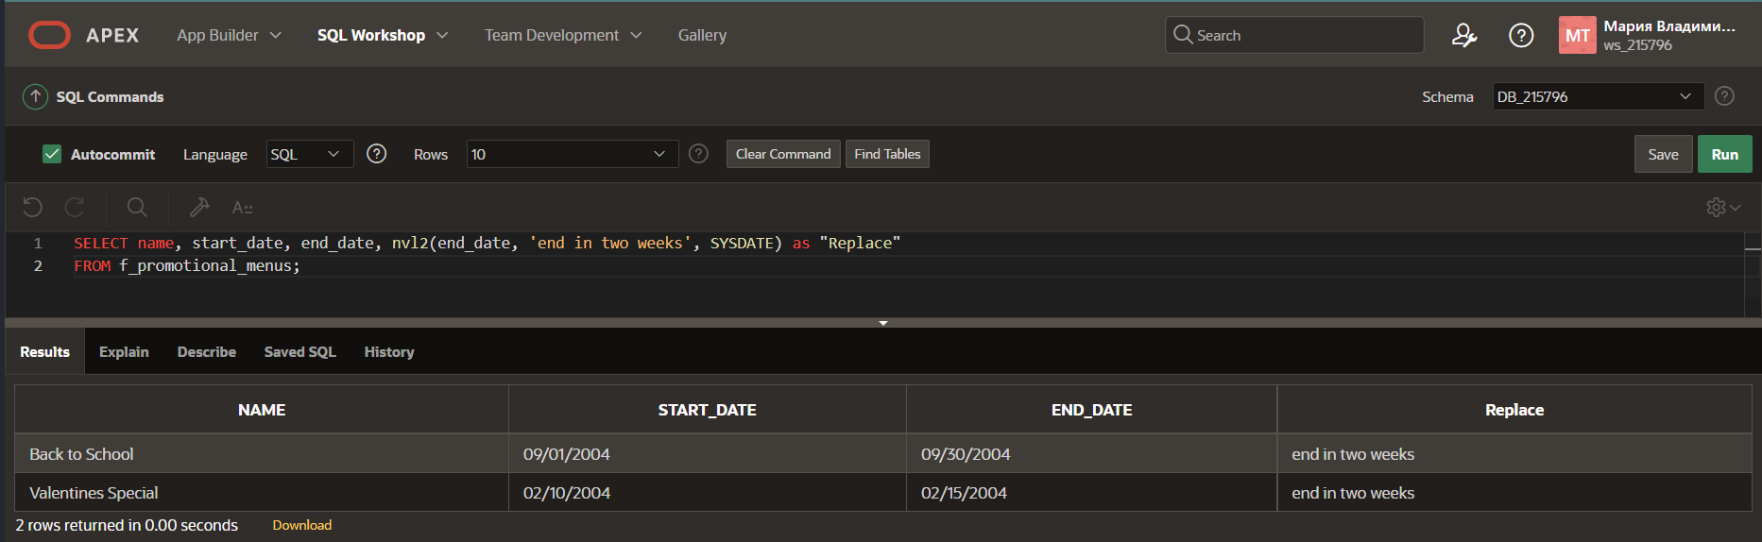

1. Not all Global Fast Foods staff members receive overtime pay. Instead of displaying a null value for these employees, replace null with zero. Include the employee’s last name and overtime rate in the output. Label the overtime rate as “Overtime Status”.

1. The manager of Global Fast Foods has decided to give all staff who currently do not earn overtime an overtime rate of $5.00. Construct a query that displays the last names and the overtime rate for each staff member, substituting $5.00 for each null overtime value.

1. Not all Global Fast Foods staff members have a manager. Create a query that displays the employee last name and 9999 in the manager ID column for these employees.

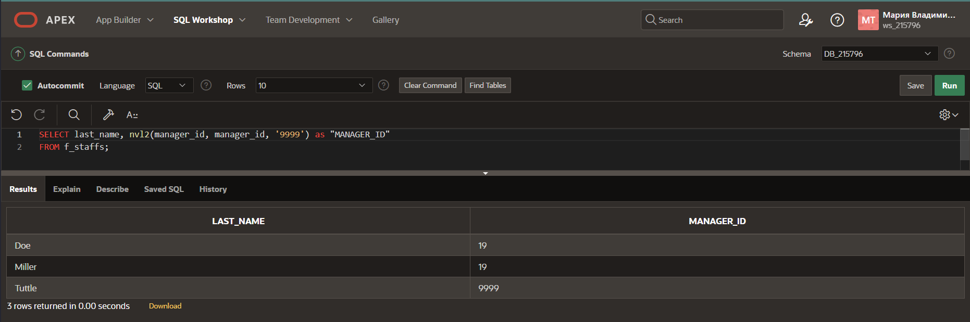

1. Which statement(s) below will return null if the value of v_sal is 50?

a. SELECT nvl(v_sal, 50) FROM emp;

b. SELECT nvl2(v_sal, 50) FROM emp;

**c. SELECT nullif(v_sal, 50) FROM emp;**

d. SELECT coalesce (v_sal, Null, 50) FROM emp;

1. What does this query on the Global Fast Foods table return?

SELECT COALESCE(last_name, to_char(manager_id)) as NAME

FROM f_staffs;

1. a. Create a report listing the first and last names and month of hire for all employees in the EMPLOYEES table (use TO_CHAR to convert hire_date to display the month).

b. Modify the report to display null if the month of hire is September. Use the NULLIF function

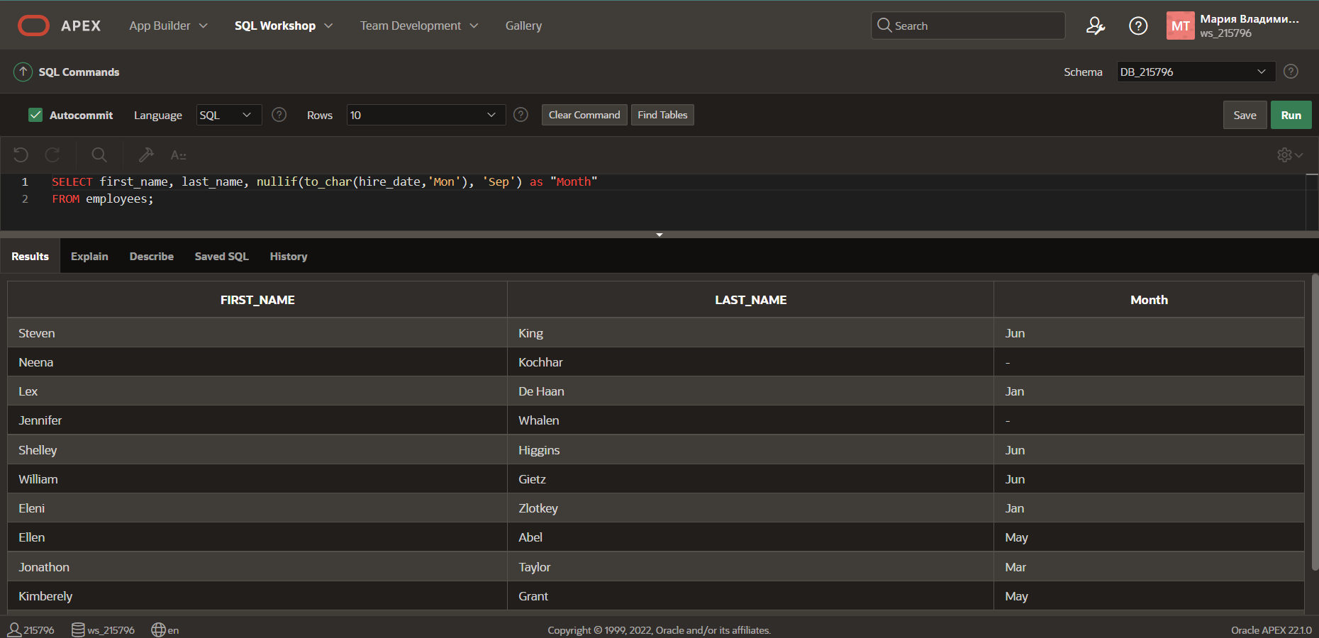

1. For all null values in the specialty column in the DJs on Demand d_partners table, substitute “No Specialty.” Show the first name and s

